anline2

Try and solve this crossword puzzle having to do with a **Computer or the Internet**

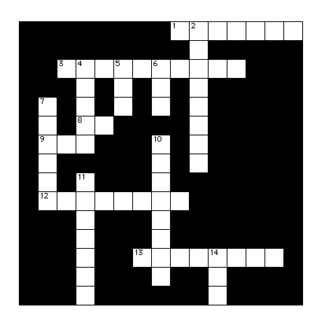

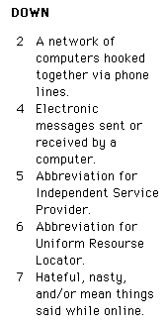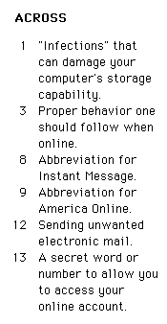

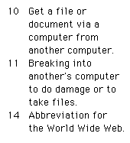

http://192.107.108.56/portfolios/r/ryter_m/Safety/xword.html